**Induction**

**Ceremony & Dinner**

**July 20, 2014**

**5:00 - 9:00 PM.**

**WoodWinds**

**29 School Ground Road**

**Branford, CT.**

# Directions to WoodWinds

**From New Haven**

**I-95 North to Exit 56. Left off the exit onto Leetes Island Rd, straight for 1/2 mile. WoodWinds is on the right.**

**From New London/Groton**

**I-95 South to Exit 56. Left at the end of the exit ramp. Straight to next light, take a right onto Leetes Island Rd. Straight for 1/2 mile. WoodWinds is on the right.**

**From Hartford**

**I-91 South to I-95 North to Exit 56. Left off the exit onto Leetes Island Rd., straight for 1/2 mile. WoodWinds is on the right.**

**Support The North Branford Athletic Hall of Fame. Only with your continued support are we able to honor outstanding individuals each year and sustain our organization.**

**Please show your Support….**

**Platinum ($100)**

**Gold ($50)**

**Silver ($25)**

**Bronze ($10)**

**Name: ________________________**

**Address: ______________________**

**City: _________________________**

**State: ________________________**

**Phone: _______________________**

**E-Mail: ______________________**

***Our Mission Statement***

***To recognize and honor the men and women who have had an exceptional impact on the athletic program at North Branford High School.***

NB

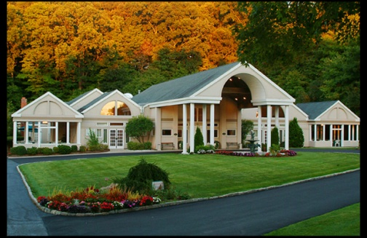



Dinner Reservation

***Accepting Reservations Until July 10th***

**Name: _____________________________**

**Address: ___________________________**

**City: ______________________________**

**State: ____________ Zip:______________**

**Phone: _____________________________**

**For which inductee are you attending:**

**Dinner seating will be assigned. All names must be listed on the reservation form. Buffet Dinner – Seating Table of 8 or 10**

**Names:**

**____________________________________**

**____________________________________**

**____________________________________**

**____________________________________**

**____________________________________**

**____________________________________**

**____________________________________**

**____________________________________**

**____________________________________**

**____________________________________**

**Tickets – *Pick-up at the Door***

**Amount at $40.00 per guest $_____**

**Make check payable to:**

**NBHS Athletic Hall of Fame**

**Mail check to: Janine Reilly**

**59 Glenwood Road**

**North Branford, CT 06471**

**The North Branford High School Athletic Hall of Fame Committee proudly announces this year’s inductees:**

***Rick Geremia***

***Boys and Girls Soccer Coach***

***1971***

***Jim Moran***

***1982***

***Jimmy Wilborn***

***1984***

***Ellen-Mary Martin-Frye***

***1992***

***Wendy Elles***

***1994***

***Karen Vissicchio Czaplicki***

***1996***

***Dan Petroskey***

***2004***

***Mike Gargiulo***

**On behalf of The North Branford High School Athletic Hall of Fame founding members, we look forward to seeing you and celebrating our fourth ceremony and dinner.**

**Committee Members:**

**Rose D’Amato**

**Patti Ferraro**

**Tricia Guyon**

**Lynn Lennon**

**Janine Reilly**

**Chris Webster**

